**Best Practice Guide**

Community Inclusion for Community Benefit

A co-designed resource for nature-based projects looking to deliver meaningful community engagement processes.

**These are printable resources to help you and your team on your community engagement journey.**

## Checklist of Actions

|  |  |  |
| --- | --- | --- |
| **Suggested best practice action** | **Relevant for my project?** | **Completed?** |
| **Identify a project which is bespoke, purposeful and location specific** | | |
| Highlight the target location on a map which can be shared with the community. Identify the Local Authority and Community Council areas within which the location sits. | Y / N |  |
| Define the community (this includes geography and demographics of people) you wish to engage through the project, and what you want to engage them on. | Y / N |  |
| Identify and document, in a way that can be shared with the community, the parameters the project is working within. This may include funding restraints, landowner wishes, investor priorities, etc. | Y / N |  |
| Take time to understand local context; local policies which impact land use, historic relationships with the land, community groups with a history of engaging (or not) with local projects, etc. | Y / N |  |
| Undertake local stakeholder mapping and an asset mapping exercise to identify skills/resourcing already available and where local community structures (e.g. land management group, community council, development trusts, educational programmes, tourism board) are already in existence which can be approached for discussion around collaboration opportunities. Tap into existing funded frameworks/groups. | Y / N |  |
| Take time to build relationships with local people and groups, engaging with existing groups where appropriate, but also creating opportunities for people not associated with a local group to engage as an individual. | Y / N |  |
| Check with any available local community-led plans (e.g. community action plans, local place plans) to identify community priorities which could be addressed by the project. | Y / N |  |
| Ensure the project has been considered in relation to wider community action plans or other ongoing community projects, identifying areas of crossover and partnership. | Y / N |  |
| Provide a list of decisions and topics that community stakeholders/participants can have direct influence over. Provide a list of parameters which the community stakeholders/participants can and cannot influence and explain why. | Y / N |  |
| Ensure scope and outcomes are clearly set – directing conversations in a positive and constructive way. | Y / N |  |
| Determine with the community the level of impact (both positive and negative) the project may have on the community. Discuss this with the community to ensure all perspectives of impact are considered. | Y / N |  |
| Highlight opportunities for community wealth building (strengthening local and regional economies) through community benefits. This will support deliberation with the community and help define parameters. | Y / N |  |
| Set expectations by building into the process what to do if parties are in conflict, have complaints, and/or are dissatisfied with the process. | Y / N |  |
| If relevant, provide guidance and training to staff on effective facilitation, mediation and building consensus methods and how to manage difficult conversations where there is contention. | Y / N |  |
| Provide information on when people should expect to see change. Expectation setting – people might not see immediate benefits but will still work towards positive change for future generations. Also be clear where timelines may be unknown, for example, if it is unknown when funding will be made available. Identify where possible risks may result in not seeing any change or the community seeing less change than expected. | Y / N |  |
| **Ensure adequate funding and resourcing** | | |
| Ensure that community engagement costs are realistically budgeted for, e.g., whether you are carrying out a light touch consultation vs. community co-design | Y / N |  |
| Include all associated costs in initial funding requirements including staffing/direct delivery costs (travel, food, gift of thanks, venues, additional support for participants, resources) | Y / N |  |
| Budgets should include communications costs relative to realistic plans for promotion including media plans and advertisement of the project. | Y / N |  |
| Identify partnership opportunities to share expertise and resources across community groups and projects (geographically and topically). This could include sharing contractors or consultants across projects where possible to increase affordability. This could also include sharing resources such as project plans. | Y / N |  |
| Work closely with local organisations (including voluntary, charity, educational institutes, etc.) and/or individuals to identify suitable roles and appropriate compensation (i.e. some groups may expect consultant pay, some may expect travel and sustenance expenses). | Y / N |  |
| Create budgets which include a day rate for community volunteers and steering groups who are involved in moving projects forward. | Y / N |  |
| Identify whether an external agency should be brought in to deliver the community engagement and whether this is covered buy available budget. For example, if the project topic is contentious and requires neutral facilitators or requires more participatory design expertise. | Y / N |  |
| Utilise existing project plans, frameworks, and evaluation methods where possible to reduce resourcing pressures. | Y / N |  |
| Consider levels of underemployment in the local community and opportunities for paid roles and training within the project. | Y / N |  |
| Ensure staff are provided with time and scope to work on project legacy, including growing the project beyond initial scope and developing new directions for the project activities, where appropriate. | Y / N |  |
| Continue to review budgets and adapt where appropriate (and in line with funding guidance) to meet evolving needs of the project. | Y / N |  |
| **Identify decision makers and build in legitimacy** | | |
| Create a diagram detailing the decision-making process, highlighting which groups feed into an evidence base and which individuals/organisations are required to sign-off on recommendations | Y / N |  |
| Utilise community engagement methods which are appropriate to the timescales provided. For example, if time is not available for meaningful co-production due to short funding periods, short land sale deadlines, etc., look to focus groups/consultation | Y / N |  |
| Be transparent with decision-making processes. Disclose relevant financial decisions which may affect communities, this may include private investment contracts including specific criteria with regards to land management. | Y / N |  |
| Identify whether a neutral facilitator should be brought in. | Y / N |  |
| Consider building Community Benefits Agreements into contractual clauses, ensuring a legal obligation and established roles and responsibilities for sustainability and longevity of community benefit. | Y / N |  |
| Share progress reports regularly: what has been done with the community, how have the outputs been utilised, and what other information has been relied on to make decisions? | Y / N |  |
| **Address imbalance through equitable and inclusive design** | | |
| Ensure capacity, appropriate staffing, and suitable budget are in place to address the individual needs of participants. | Y / N |  |
| Identify the demographics which are present in the local area and ensure you have both diversity and representation in the participant group as much as possible (which acknowledging that not everyone in a community will be interested in participating). | Y / N |  |
| Consider all protected characteristics and the intersectionality of all participants. | Y / N |  |
| Have a range of engagement methods available to meet varied needs of community members. For example, online, offline, anonymous feedback, written, spoken, voting activities, etc. | Y / N |  |
| Consider how to meet additional support needs participants may have, including (but not limited to) mobility issues, language barriers, the need for an advocate in the room, resources/materials in alternative formats, provision of childcare, travel allowance, etc. | Y / N |  |
| Produce an accessible glossary for some jargon/terms (including the language of financiers) and minimise use of technical language where possible | Y / N |  |
| Use inclusive and positive language – use neutral examples to avoid unconscious bias. | Y / N |  |
| Have clear participation guidelines in place to support inclusion and address power imbalances during deliberation. | Y / N |  |
| **Communicate effectively with different audiences** | | |
| Explore a combination of ways to communicate to the community such as letter drop, social media ads, newsletter, word-of mouth, attending groups and existing spaces such as libraries, supermarkets, etc and developing a combination of written and visual methods such as posters, images and videos. | Y / N |  |
| Use local and/or similar practical examples and case studies, for example:   * take a picture of the local landscape and label it with different terms   use film/audio-visual media to communicate local messages | Y / N |  |
| Stakeholder mapping – identify experts on relevant topics to support clear communications | Y / N |  |
| Interact with local groups to support regular discussions, create appropriate forums where no such local groups exist. | Y / N |  |
| Ensure community feedback opportunities are available to identify which methods of engagement are successful. | Y / N |  |
| Explore opportunities for community-led communications, such as podcasts and/or vlogs | Y / N |  |
| Utilise visual tools where possible, e.g. story-mapping | Y / N |  |
| **Plan accessible stakeholder recruitment and onboarding** | | |
| Have a dedicated, public-facing point of contact for the community to speak to directly, supporting understanding while addressing concerns and building connections. | Y / N |  |
| Consider innovative ways to engage with people who don't normally participate in standard community engagement processes. For example, using arts and theatre activities to engage people. | Y / N |  |
| Understand a range of learning styles (e.g. visual, practical, listening, etc.) and develop a process which is accommodating of diverse participation needs. | Y / N |  |
| Use a mix of in-person and online methods of communication, ensuring people have the time to communicate in a way (and location) they feel comfortable in. | Y / N |  |
| Gather informed consent from participants to support evidence gathering and sharing of outputs publicly and/or with auditors, including consent to take part, to hold information, for photographs, for use of names, etc. | Y / N |  |
| Remove any potential burdens engaging might put on an individual – pay gift of thanks, provide transport, host sessions over a range of time, etc. | Y / N |  |
| Recognise, highlight and value different groups within the community (landowners, business owners, residents, service employees/providers, etc.) | Y / N |  |
| Create opportunities for individual conversation, utilising spaces in which individuals will be comfortable engaging one-to-one. Make use of local community spaces (e.g. pubs, community halls, local hubs). This supports relationships between the project team and the community, and provides a safe space for community members to ask clarifying questions or raise concerns which they do not feel comfortable sharing in a public space. | Y / N |  |
| Recognise that not everyone wants to be involved; celebrate and value those that do. | Y / N |  |
| **Work reflexively and adaptively to meet community needs** | | |
| Create flexible plans to meet the needs of each specific community. | Y / N |  |
| Be flexible and bring in new/other voices as they emerge. | Y / N |  |
| Schedule regular meetings with a core project management group to review progress against timelines, identify possible risks, and implement mitigation measures where appropriate. | Y / N |  |
| Regularly communicate with the community, sharing successes, achievements, challenges, etc. | Y / N |  |
| Create space for connection: shared learning events, volunteer training, etc. | Y / N |  |
| Bring people together to share understandings of restrictions, values and remove possible conflict - explore shared values and common ground. | Y / N |  |
| **Plan for longevity and lasting community relationships** | | |
| Assign staff time to sourcing follow-up funding from inception (utilising existing funding and capacity) | Y / N |  |
| Identify where local advisors/consultants are available to help communities and investors build connections. Sometimes it can be beneficial to bring a neutral, third party in to provide expertise and advice that doesn't have a local connection to, or a direct vested interest in, the project. | Y / N |  |
| Where project teams are likely to change, plan for continuity for the community. | Y / N |  |
| **Embed evaluation, learning and impact** | | |
| Consider monitoring and evaluation measures of community engagement and of delivery of any agreed outcomes and/or community benefits. | Y / N |  |
| Determine initial community baselines and follow-up measures of engagement with appropriate frameworks/metrics. | Y / N |  |
| Evidence wider economic impacts where possible (e.g. number of jobs brought to the area). | Y / N |  |
| Utilise and evidence best practice frameworks. | Y / N |  |
| Share progress reports, highlighting community benefits delivered by the project. | Y / N |  |

## Stakeholder mapping visual

This is a simplified example to provide guidance and a starting point for stakeholder mapping exercises.

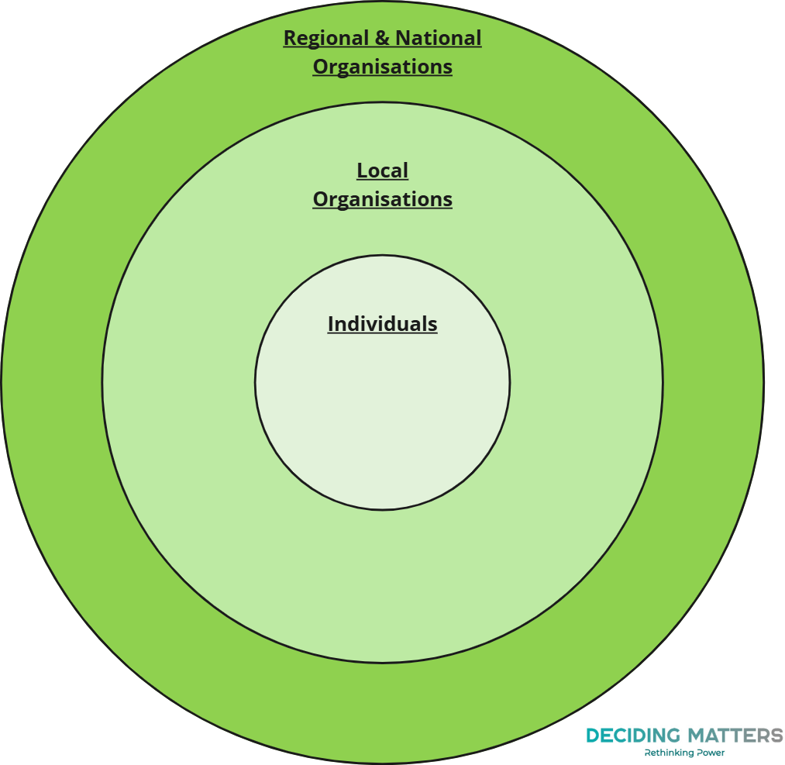

## Example consent form

**Privacy Policy and Data Use**

By completing this form, you consent to **[Organisation]** holding data that you choose to share in this form, and in interviews you choose to take part in.

**[Organisation]** will hold your information securely and only for the purpose of this specific piece of work. You can read [**data controller]**'s privacy policy here: **[inset link to policy]**

**For Participant to Complete**

|  |  |  |
| --- | --- | --- |
| Full Name: |  | |
| Contact Details [as relevant for project, e.g. phone number, email]: |  | |
| I consent to taking part in the **[project]** with **[Organisation]**, and to **[Organisation]** collecting and processing the information that I provide, in line with **controller's** data handling and privacy policies: | **Yes, I consent** | **No, I do not consent** |

**[Organisation]** may take pictures/videos/recordings at **[provide information around use for media captured, e.g. reporting, social media, audit, website, promotion, etc.]**.  
**[Organisation]** will hold photos/videos/audio recordings in line with **[relevant policies/legislation]**.

You may remove permission for your data and likeness at any time, or ask for more information about the use of your data, by **[process for removing permissions].**

I have read and understood the information above and give my consent for **[Organisations]** to use audio recordings or excerpts of recordings of me:

|  |  |  |
| --- | --- | --- |
| *(Example list of uses for media consents)* | **Yes, I consent** | **No, I do not consent** |
| I give my consent for **[Organisation]** to use images taken of me and images of materials I have produced at events: |  |  |
| I give my consent for **[Organisation]** to use videos of me taken at events: |  |  |
| I give my consent for **[Organisation]** to use audio recordings of me taken at events: |  |  |

|  |  |  |
| --- | --- | --- |
| **[Organisation]** may seek certification to validate and verify community engagement processes undertaken and Auditors may ask to speak to participants. Do you give **[Organisation]** permission to pass your name and contact details onto an auditing team to discuss a certification process? | **Yes, I consent** | **No, I do not consent** |

|  |  |
| --- | --- |
| Signature: |  |
| Printed Name: |  |
| Date: |  |

## Wellbeing web

A wellbeing web is a simple tool used to capture an individuals’ feeling towards project outcomes. The web would be used multiple times through the life of a project, producing a visual of outcomes which have shifted either positively or negatively. Desired outcomes are translated into appropriate statements which are then graded on a scale of 1-10 by the participant and marked on the web.

Example below:

**Please use the web below to mark how much you agree or disagree with the following statements:**

|  |  |  |  |  |  |  |  |  |  |
| --- | --- | --- | --- | --- | --- | --- | --- | --- | --- |
| **1** | **2** | **3** | **4** | **5** | **6** | **7** | **8** | **9** | **10** |
| **Strongly Disagree** | | |  | | |  | **Strongly Agree** | | |

* I currently have easy access to green space.
* I am confident that nature-finance will bring benefits to the community.
* The community is involved in and listened to during decision-making.
* I feel physically and mentally healthy.
* The project is clear and transparent in its objectives and actions.
* There are learning opportunities for me as a result of the project.
* Jobs and volunteering opportunities are available in the area as a result of the project.
* I feel climate anxiety.



Climate anxiety

Access to green space

Education opportunities

Jobs and volunteering

Confidence in nature-finance

Community decision-making

Health and wellbeing

Project transparency